№6
CREATE TABLE Patients
(ID int IDENTITY (1,1),
FirstName NVARCHAR(50),
LastName NVARCHAR(50),
SSN AS NEWID(),
Email AS CONCAT (UPPER (LEFT (FirstName, 1)), LOWER (LEFT (LastName, 3)), '@mail.com'),
Temp DECIMAL(5,1),
CreatedDate DATETIME,
)
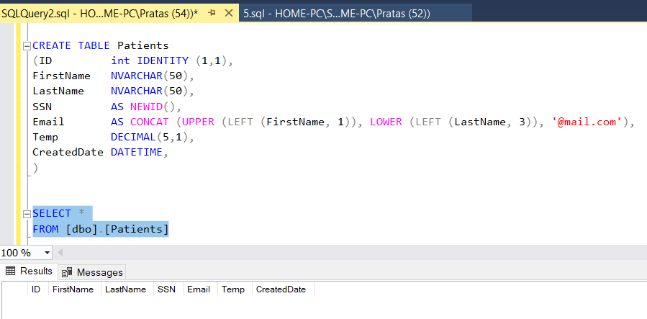

№7
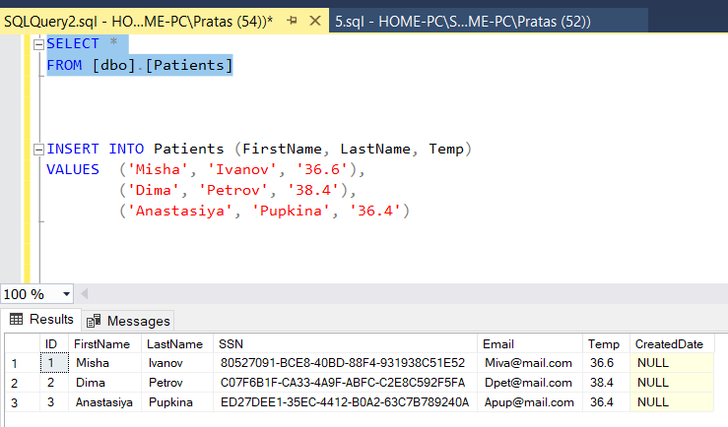
№8 Включил 37 градусов во второе условие(можно было оставить 37 а также указать ELSE)
ALTER TABLE Patients
ADD TempType AS CASE
WHEN Temp < 37 THEN '< 37°C'
WHEN Temp >= 37 THEN '>= 37°C'
END
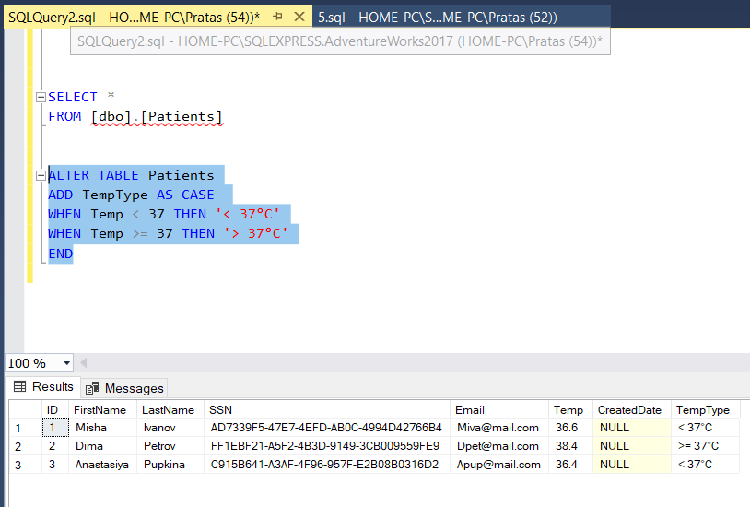
№9
CREATE VIEW Patients_v
AS
SELECT *, (Temp * 1.8 +32) AS TempF
FROM Patients
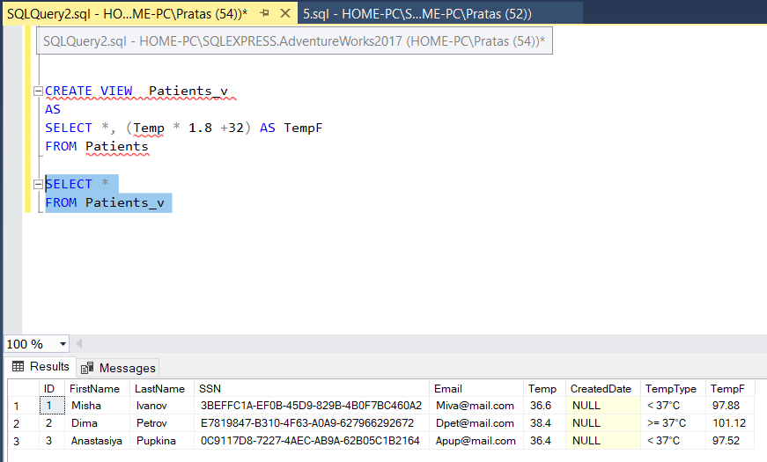

№10
CREATE FUNCTION TempFRG (@Temp_F DECIMAL(5,2))
RETURNS DECIMAL(5,2)
AS
BEGIN
RETURN (@Temp_F * 1.8 + 32)
END

--
SELECT [dbo].[TempFRG] (40.10) TEMP_2;
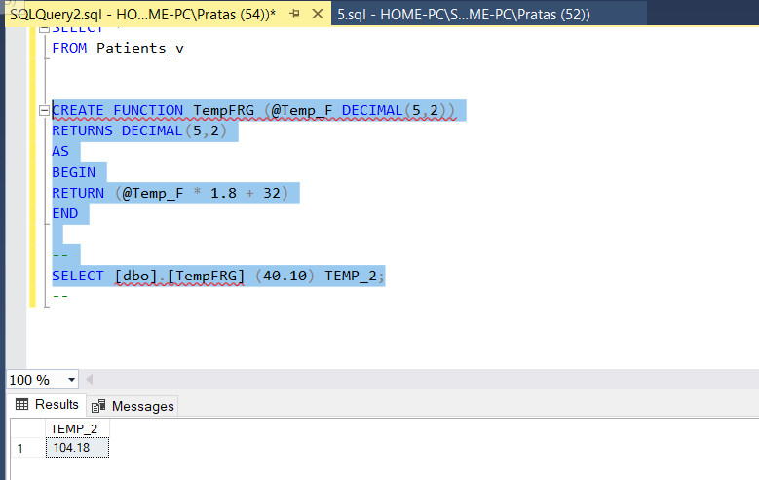

№11 При помощи переменной проще применить поиск по любому месяцу первого рабочего дня.
DECLARE @Date DATETIME, @MonthAgo INT;
SET @Date = GETDATE();
SET @MonthAgo = - 1;
SELECT CASE
WHEN DATEPART (DW, EOMONTH (@Date, @MonthAgo)) = 7 THEN DATEADD (DAY, 2, EOMONTH (@Date, @MonthAgo))
WHEN DATEPART (DW, EOMONTH (@Date, @MonthAgo)) = 6 THEN DATEADD (DAY, 3, EOMONTH (@Date, @MonthAgo))
ELSE DATEADD (DAY, 1, EOMONTH (@Date, @MonthAgo))
END

